
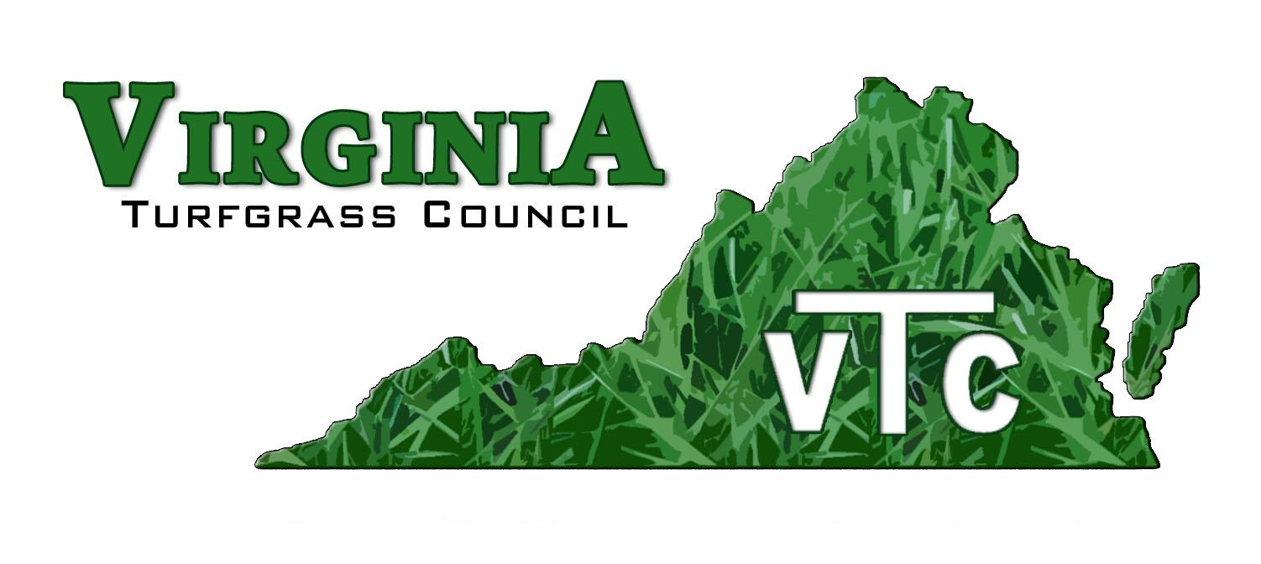

757-681-6065 Email: virginiaturf@gmail.com

March 11, 2026

Amanda Strouse
Pesticide Mgt: Certification and Training
Delaware Department of Agriculture
2320 South DuPont Highway
Dover DE 19901

Dear Amanda,

Thank you so very much for allowing us to provide pesticide recertification credit for the March 04 and March 05 webinars. Here is a list of persons who successfully completed the March 04 event – no one who attended on March is seeking credit from Delaware.

Here are the approval codes for the class: 260322-PA; 260322-03; 260322-03.

Here is the list of course completers:

Name Steven Alderman
Pesticide License Number 16-524
Email Address REDACTED
Phone Number REDACTED
Mailing Address REDACTED
Company/Employer REDACTED

Name Michael Cocino
Pesticide License Number 15-187
Email Address REDACTED
Phone Number REDACTED
Mailing Address REDACTED
Company/Employer REDACTED

Name Tom Ford
Pesticide License Number 17-632
Email Address thomasfordsb2@gmail.com
Phone Number (732) 299-6379
Mailing Address 12808 Pintail Drive Ocean City, MD, 21842
Company/Employer Cripple Creek Golf and Country Club

Name James Palokas
Pesticide License Number 08-801

Name Jason Wildt Stuart
Pesticide License Number 20-194
Email Address REDACTED
Phone Number REDACTED
Mailing Address REDACTED
Company/Employer REDACTED

Name Barry Zeigler
Pesticide License Number 29194-98331
Email Address REDACTED
Phone Number REDACTED
Mailing Address REDACTED
Company/Employer REDACTED

Thanks again for allowing us to provide training for persons who apply pesticides in your state.

Sincerely,
Tom Tracy
Tom Tracy, Executive Director (Retired)

Mobile: 757-681-6065

