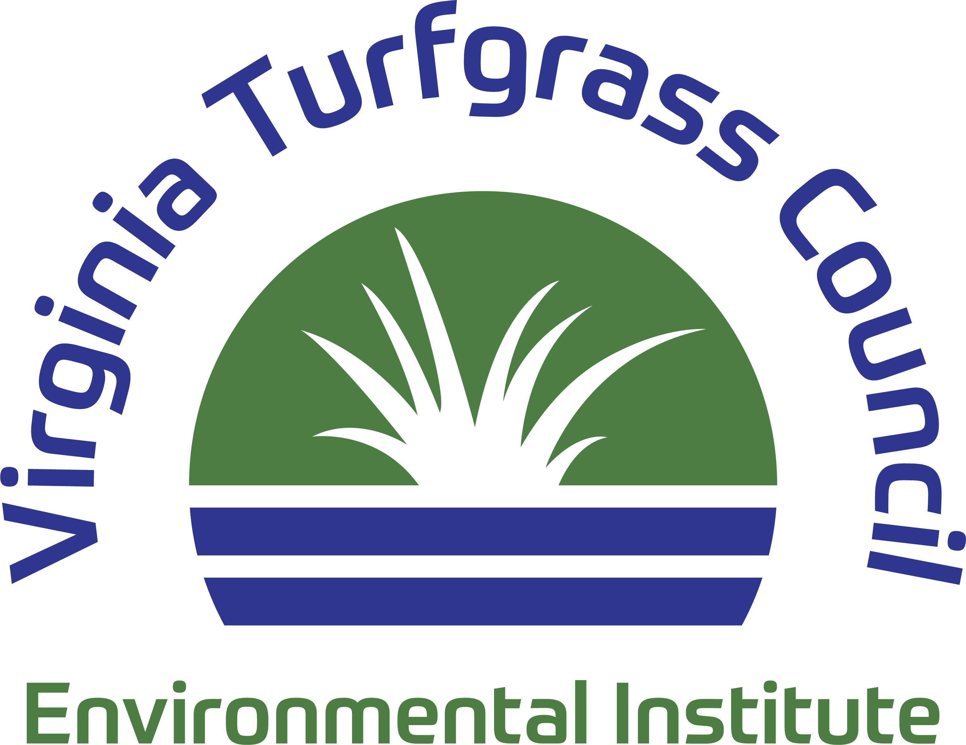

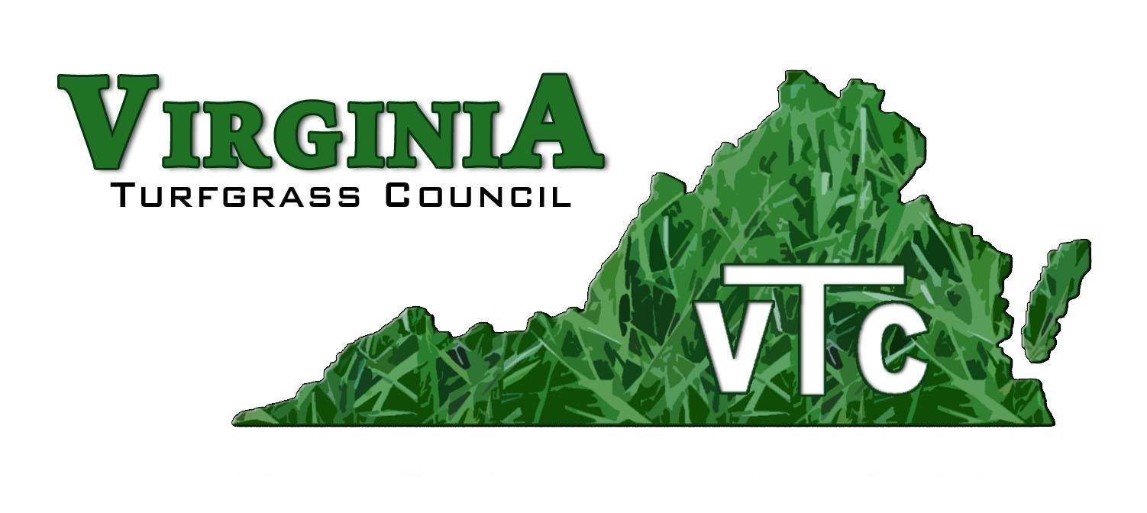

*PO Box 5989, Virginia Beach, Virginia, 23471 757-464-1004 Email: virginiaturf@gmail.com*

The Board of Directors of the Virginia Turfgrass Council and the Virginia Turfgrass Council Environmental Institute (VTC-EI) is seeking an Executive Director, with the person beginning work this fall. Not having a physical office, the person selected will need to provide the location and facilities required to conduct the work of both organizations.

Persons interested in this position need to send a resume and a cover letter that includes desired financial compensation by July 31 to virginiaturf@gmail.com

Interviews will be via zoom and will be conducted from August 11 to 22. The person selected for the position will be a 1099 Contractor, not an employee.

Questions should be directed to Wes Bray, President, at wemows@aol.com, Harris Wheeler, Vice-President, at harrisrwheeler@gmail.com, or Phil Bailey, Past President, at creeksuper@gmail.com.

Listed below is a detailed list of Executive Director responsibilities. The list is not comprehensive, other duties will be expected. Items on the list fit into three broad emphases: fund raising, member services, and legislative advocacy.

Main Areas of Responsibility

1) Administration

* Developing and maintaining the web site
* Being the main point of contact, including telephone, email, and fax
* Providing a physical business location
* Providing a PO Box (optional if the physical business location is used to receive mail)
* Processing Mail/Payments/Expenses and ensuring proper accounting principles are followed
* Sending necessary forms to the IRS for the VTC and for the VTC-EI
* Sending necessary forms to State for the VTC and for the VTC-EI. Maintaining registration with the SCC
* Monitor the Edward Jones savings account
* Work closely with the Board of Directors
* Develop the bi-monthly VTC Journal
* Conduct membership drives and encourage persons to renew each year

2) Develop and Administer the Following Events

* Come to the Bay
* Road Show
* Service Projects (Va Beach, NoVa, etc.)
* Va Beach Field Day (HR-AREC)
* Short Course

3) Legislation

* Seed Distribution
* Monitor legislation and take appropriate action
* Develop and maintain relationships with legislators
* Ensure steps are taken to sponsor the Agriculture Legislative Banquet

4) Regulatory Issues

* Develop and maintain relationships with state regulatory agencies, with special attention to VDACS.
* Annually update and seek approval for on-line/on-demand pesticide and fertilizer recertification classes
* Develop and conduct on site pesticide and fertilizer recertification classes for Platinum Members
* Assist Landscape Supply with spring pest webinar (may not be an issue in 2026)
* Develop and conduct pesticide and fertilizer certification and recertification classes at events, including Come to the Bay, the Road Show, and the HR-AREC Field Day (R)

5) Help the Board Identify Future Endeavors, including the following

* Homeowner/Conservation Day
* EI Partner Program
* EI Fund Raising
* Outstanding Legislator Award

Vision Statement:

*To become the industry leader in political advocacy, certification, education, and environmental stewardship in the lawn and landscape industry*

Mission Statement

*To ensure that our members and businesses in the lawn and landscape industry succeed through representation, education, and community outreach.*

The purposes of Virginia Turfgrass Council Environmental Institute are:

1. Providing education for industry professionals and the general public on proper practices for environmental protection through various means, including seminars and workshops.

2. Providing opportunities for industry professionals and the general public to restore environments.

3. Encouraging and providing support for environmental research.

4. Educating decision makers about proper industry practices that protect the environment.

*The Virginia Turfgrass Council and the Virginia Turfgrass Council Environmental Institute are equal opportunity associations. We offer a welcoming and inclusive environment in service to one another, our advocacy, the diverse industry professionals. We do all of this with kindness, empathy and respect for each other.*