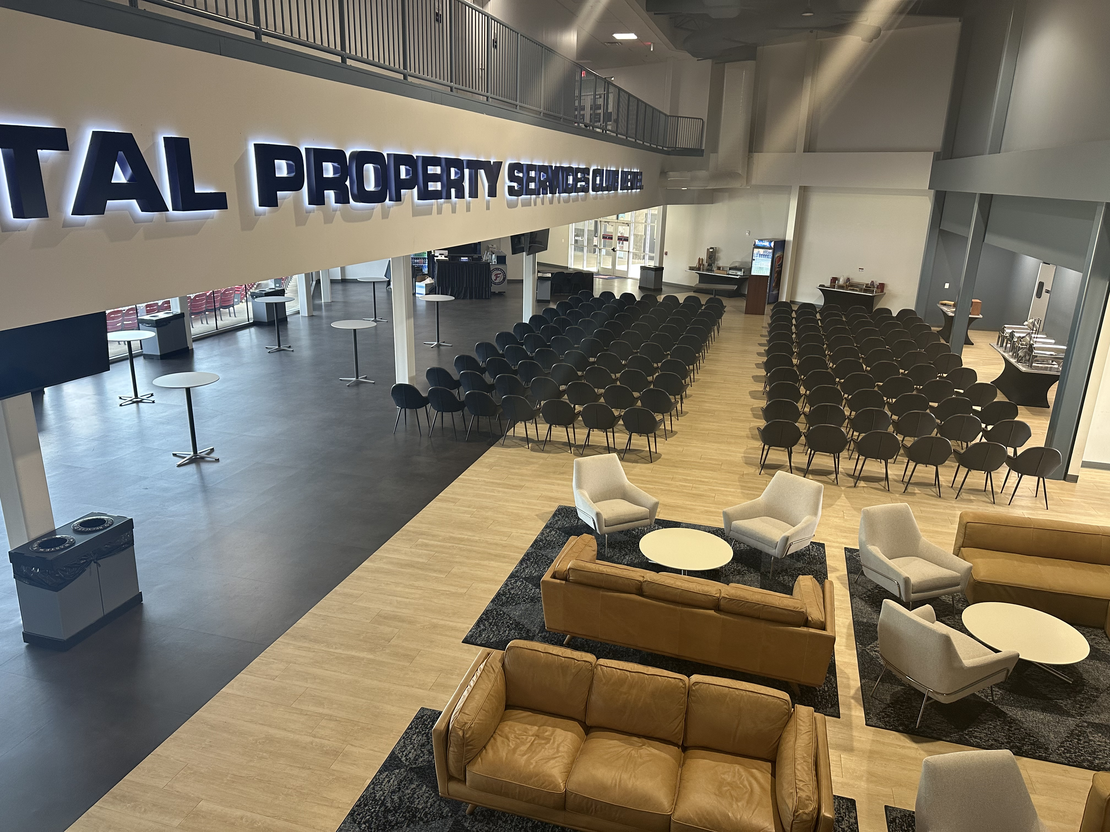

2025 Fredericksburg Road Show
Fredericksburg Nationals Ballpark (42 Jackie Robinson Way, Fredericksburg, VA 22401)

VIRGINIA TECH, VIRGINIA COOPERATIVE EXTENSION, VIRGINIA TURFGRASS COUNCIL
RECERTIFICATIONS OFFERED
Virginia Pesticide Applicator: Pending (3A, 3B, 5A, 6, 8, 10, 60)
Maryland Pesticide Applicator: Pending
Virginia Certified Fertilizer Applicator

DATE
February 26th – Fredericksburg

PRICE (Check One)
$40.00 for VTC Members
DRAFT SCHEDULE
7:00 – 7:30 Registration
10:00 – 10:30 Break and Visit Vendors
12:00 – 1:00 Lunch and Visit Vendors
4:00 – 4:15 Complete Paperwork and Depart

$60.00 for Non-VTC Members
$130 Attend and Join the VTC
$300 Vendor (Includes a table; chairs; and one registration)

Lunch is provided for all attendees by our vendors

Make Checks Payable To: Virginia Turfgrass Council, P.O. Box 5989, Virginia Beach, VA 23471.
Or Register and Pay On-line at https://vaturf.org/road-shows/
Or Charge to Credit Card: Check one: MC/VISA Am. Expr. And fax to 757-282-2693

Card #_____________________________________________________Exp.Date___/___
Security Code ______

Signature___________________________________________________________Date___/___/___

PLEASE TYPE OR PRINT CLEARLY:

Name: Email: .

Company: Phone:(_____)_________________

Address:_______________________________________________________Fax:(_____)___________________

City:___________________________________________State:____________________Zip:________________
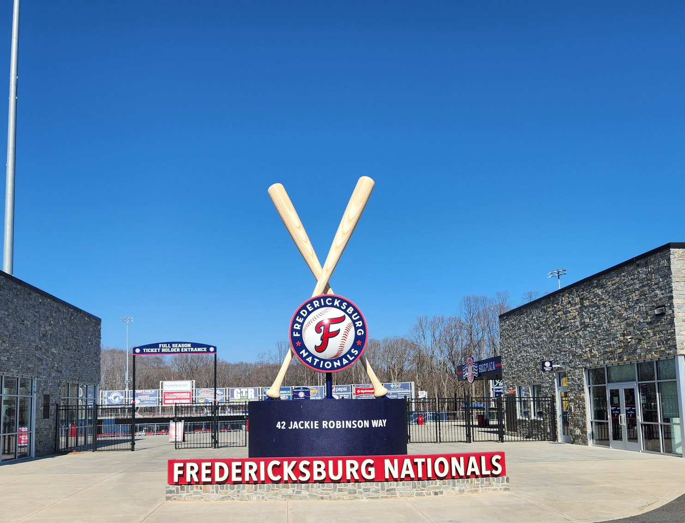

VTC
PO Box 5989
Virginia Beach, VA 23471
(757) 464-1004
vaturf@verizon.net

Fax: 757-282-2693
Web: www.vaturf.org

