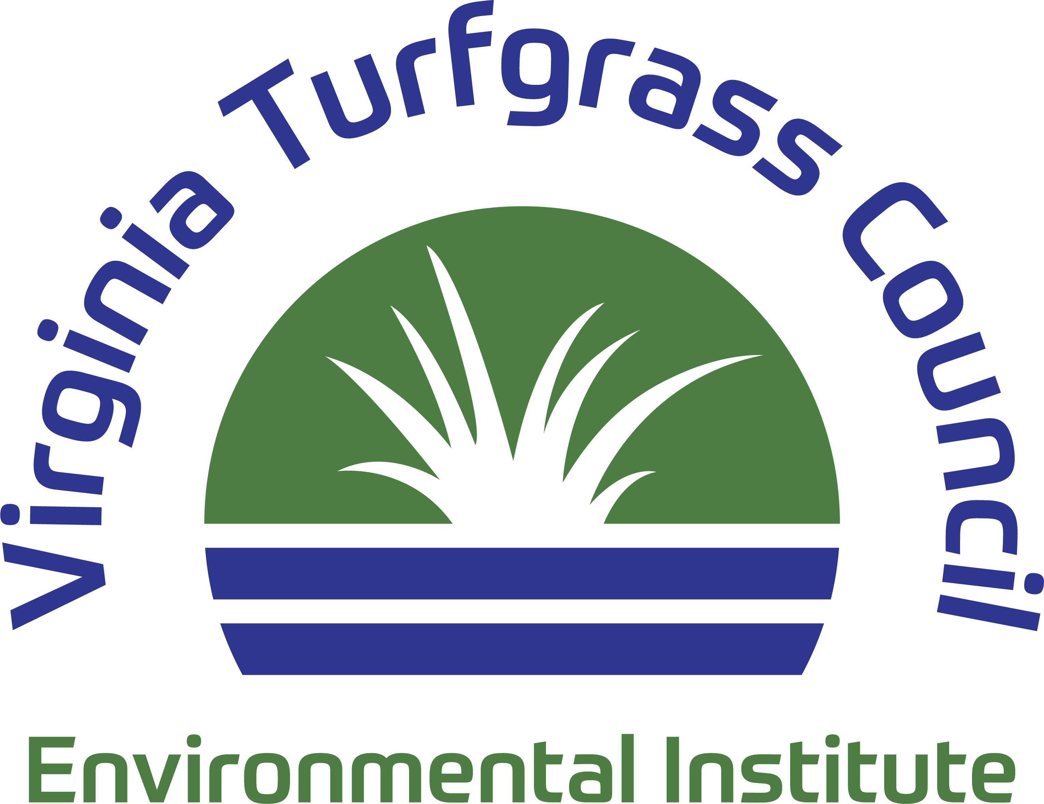

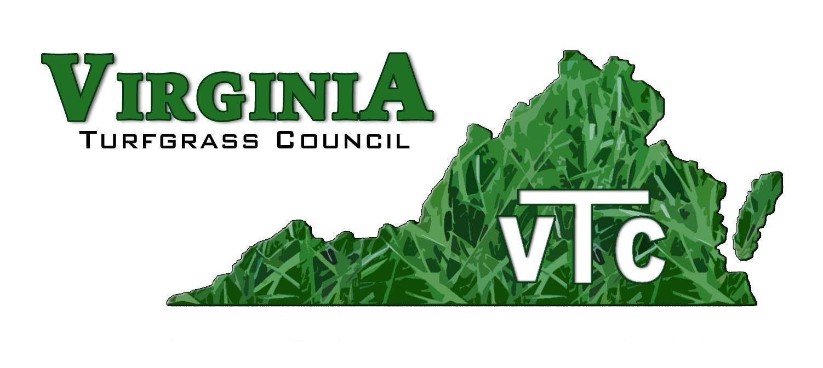

*PO Box 5989, Virginia Beach, Virginia, 23471 757-464-1004 Email: virginiaturf@gmail.com*

**August 2024 Update**

Dear Industry Professional,

The HR-AREC needs a dedicated PhD Turf Specialist to research needs of industry members who grow, install and maintain warm season grasses.

As recently as 2000, warm-season turfgrasses, such as Saint Augustine, Seashore Paspalum, Centipedegrass, and many cultivars of Bermudagrass were rare in Virginia – they were relegated to our southern neighbors. Now, these plants are regularly grown in Eastern Virginia.   
  
We need robust research to guide us in establishing policy that will mitigate the urban heat island effect, something that turfgrasses are uniquely positioned to do. Additionally, turfgrasses are nature’s filtration device, removing all manner of natural and man-made pollutants from the environment and incorporating those elements into their tissue in a process known as bioremediation.

For the State of Virginia, our challenge is to foster a program that incorporates the warm-season turfgrasses; plants that are not hardy enough to withstand the cold winters of much of Virginia. With the addition of a Ph.D. level position at Hampton Roads, the turfgrass program at Virginia Tech will continue to expand and serve our state.

The need for such a position is highlighted by industry leaders choosing to send their children to southern universities because of the strength of those institutions in warm-season turfgrass. One such leader is the owner of an expanding business that currently has 85 employees and services over 17,180 lawns. He is willing to pay out-of-state tuition because his son needs to focus on warm-season turfgrass.

On Thursday, July 11, Wes Bray, Harris Wheeler, Craig Zeigler, and Tom Tracy (VTC President, Vice President, Board Member, and Director, respectively) traveled to Blacksburg to meet with Virginia Tech officials regarding ways of meeting the industry need for increased research on warm-season turfgrasses.. They met with Virginia Tech researchers Mike Goatley, David McCall and several administrators.     
    
We presented letters expressing the need for additional research from

* National Association of Landscape Professionals,
* Virginia Agribusiness Council,
* Virginia Sports Field Management Association,
* Agronomic Lawn Management, and from the
* VTC Environmental Institute.

Several promising paths towards a solution were discussed. It is too early to mention details but we will keep you posted.

So, what are you doing to help? Service projects success depend on your willingness to volunteer time

and provide financial support. I encourage you to look around your communities and be more involved.

Our work continues. Your support enables us to keep fighting for you! Please donate to the VTC Environmental Institute. Because we are a 501-c3 corporation, your donations are tax-exempt. Use the attached form or go to *https://vaturf.org/donate_institute* to donate on-line.

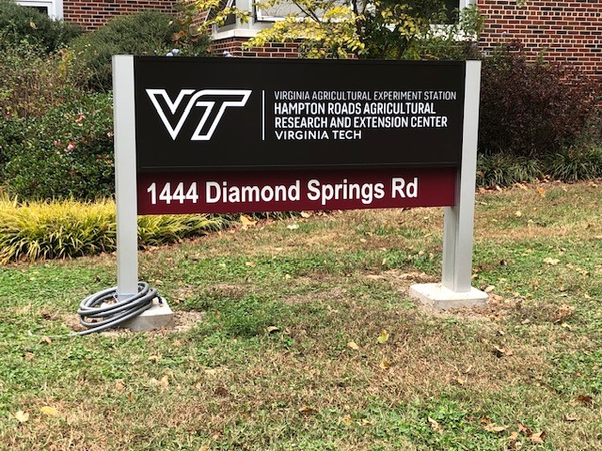

Sincerely,

Wes Bray

Wes Bray, President

Tom Tracy

Tom Tracy, Executive Director