
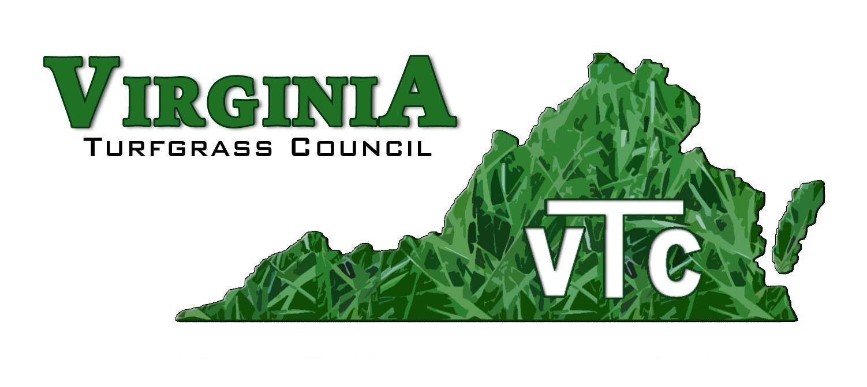

PO Box 5989, Virginia Beach, Virginia, 23471 757-464-1004 Email: virginiaturf@gmail.com

May 2024 Update

Dear

You are receiving this letter because you have either donated time, money, or other resources to the Virginia Turfgrass Council Environmental Institute (VTC-EI). Thank you! Your donation enables us to further our mission of advocating for our industry with elected officials, key persons in regulatory agencies, environmental group leaders, and many others.

Our industry is under attack. We don’t need to tell you that basic fact. In most, if not all, of the measures that concern us are led by misinformed individuals who pass legislation or establish regulations that limit your ability to conduct business. Remember, one stroke of the pen or one vote by an uninformed person is all it takes to destroy your livelihood.

We have been very busy these past few months interacting with those persons who affect our great industry. Here are just two examples.

Distributing Grass Seed to Elected Officials in the General Assembly
On Tuesday, February 13th, we distributed 300 three-pound bags of fescue grass seed to members of the General Assembly. These seed bags were generously packaged and provided and delivered by Trinity Turf. This annual seed distribution is a great opportunity to make connections with policy makers and to represent the interests of our members.
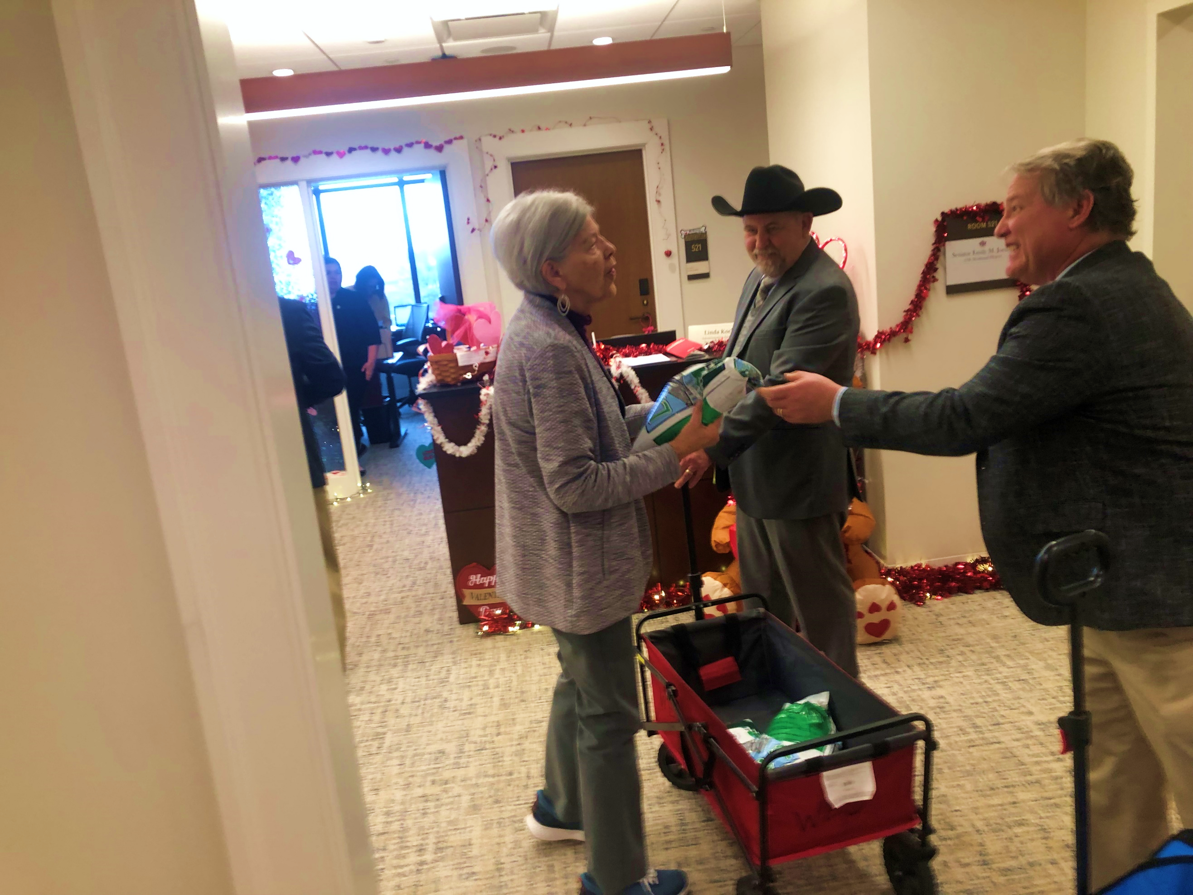
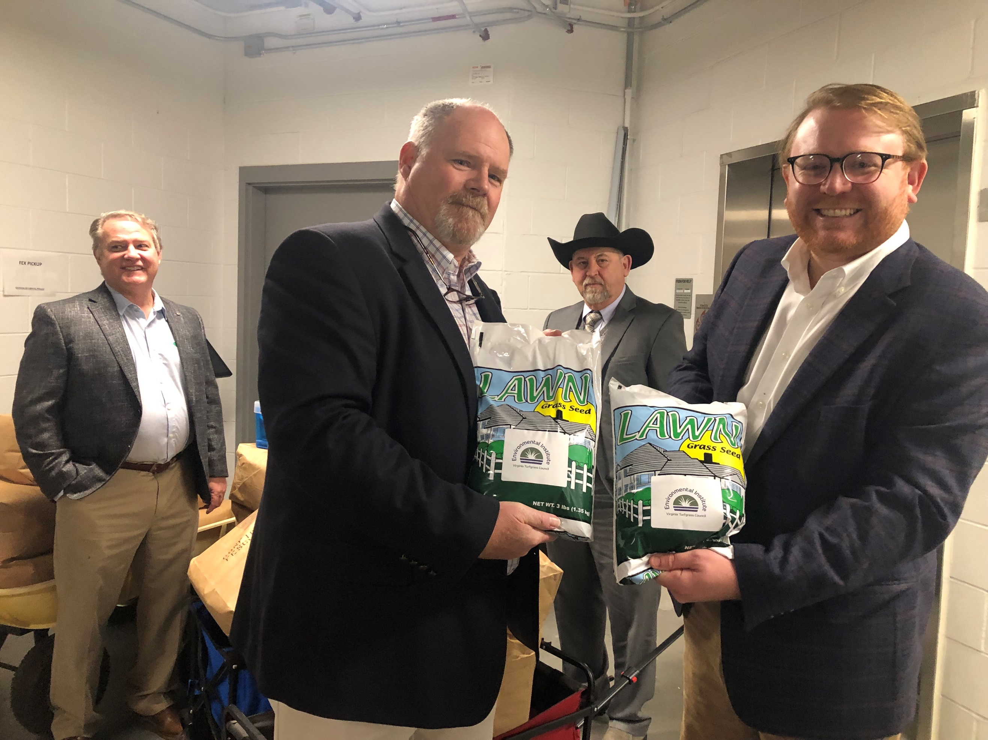

Service Project in Partnership with the Virginia Aquarium and Virginia Beach City Public Schools
Many hours of preparatory work and extensive planning came to fruition on January 22 with two environmental projects at the Virginia Aquarium: installing coir logs to prevent erosion and installing native plants around a demonstration wetland pond. The projects were only possible because of tremendous support from Virginia Beach City Public Schools, the Virginia Aquarium, and many industry leaders.

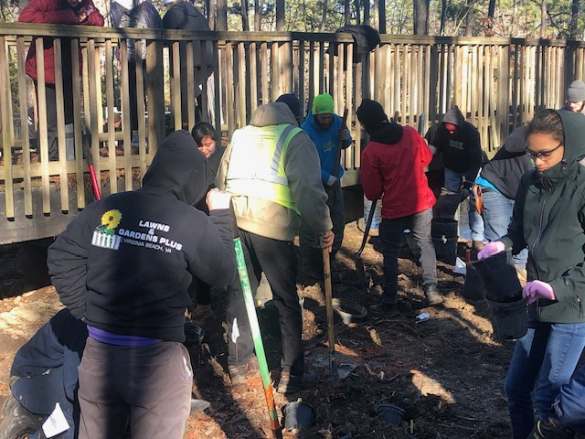

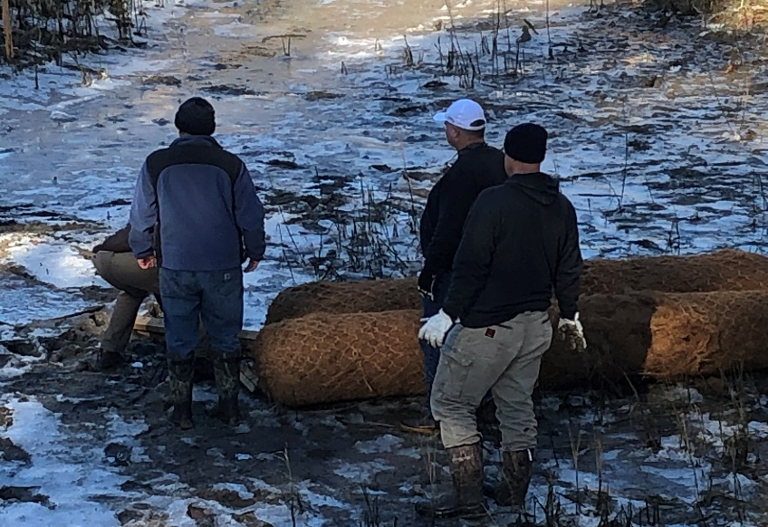

Please continue to support the VTC-EI. Our outreach and advocacy are only possible because of you, members of the green industry. You may use the attached form or else go to https://vaturf.org/donate_institute to donate. Your gifts are tax-deductible since we are a 501-c3 corporation.

Sincerely,

Wes Bray
Wes Bray, President

Tom Tracy
Tom Tracy, Executive Director

