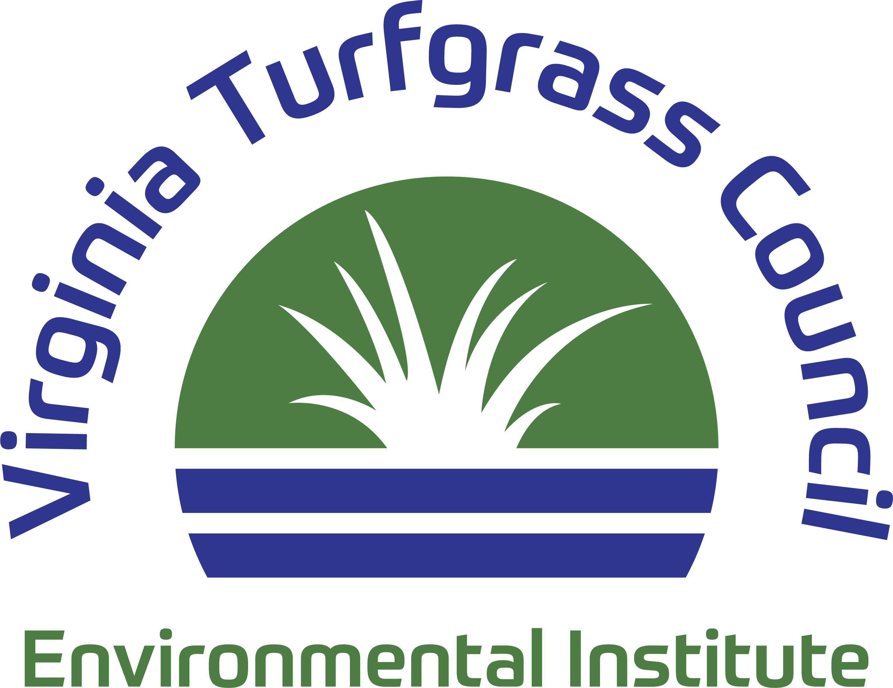

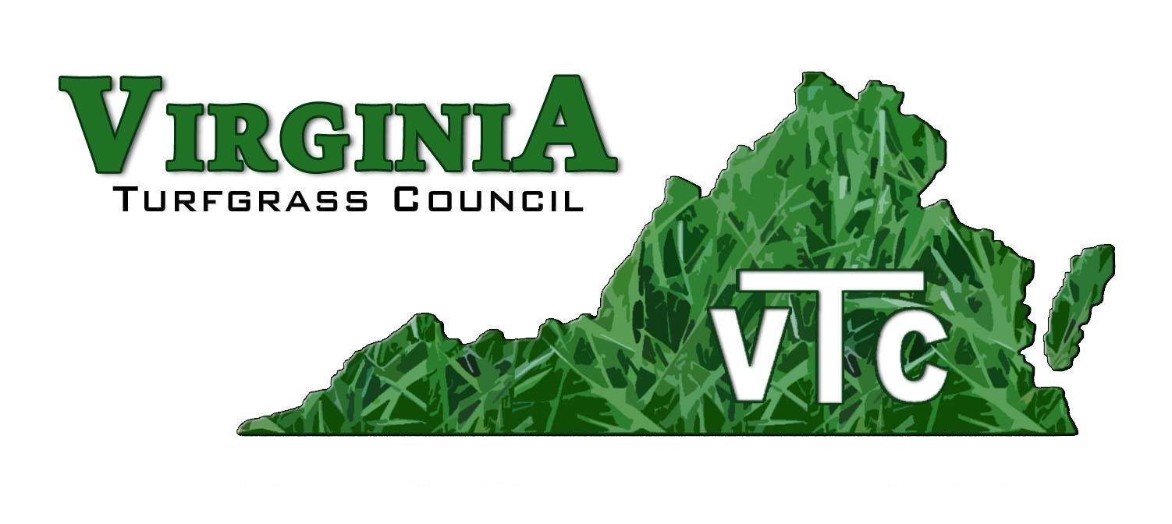

*PO Box 5989, Virginia Beach, Virginia, 23471 757-464-1004 Email: virginiaturf@gmail.com*

**June 2024 Update**

Dear Industry Professional,

Elected officials can make or break our industry with a stroke of the pen. That power is especially possessed by members of Virginia’s General Assembly and that truth propels our involvement with legislators. We take stands on specific bills and we broadcast the value of our great industry to elected officials throughout the year.

Annually distributing 330 bags of fescue grass seed to senators, delegates, and their aides is one of our major outreaches. “We look forward to your coming,” is frequently heard as we pull our wagons full of seeds through the General Assembly building. The three-pound seed bags were donated by Trinty Turf – that company even custom blended and custom labeled each bag for us.

Three bills that caught our attention during the 2024 General Assembly: HB320, HB528, and HB644

**House Bill 320** allows unlicensed volunteers to apply herbicides on select city and county land throughout the state. While the intent of the legislation, controlling invasive weeds, is admirable and pursues a goal we all endorse, using a technicality to bypass the training, certification, and recertification requirements established by the Environmental Protection Agency and the Virginia Department of Agriculture and Consumer Services is worrisome. We expressed our concern – to no avail. The bill passed the General Assembly and has been signed into law by Governor Youngkin.

The new freedom granted in the regulation is not mandatory – it only allows localities to use volunteers. They are not required to do so. Concerns about liability have already prompted several cities and counties to not allow volunteers to apply pesticides.

On a side note, the group that pushed the bill through the General Assembly is on record as saying herbicides are necessary. That truth is rarely heard from persons opposed to pesticides.

**House Bill 528** sought to require Home Owner Associations to allow residents to replace lawns with conservation landscapes. We expressed our concerns but the issue addressed by the bill primarily is primarily a property rights one. The bill was carried over to the 2025 Session.

**House Bill 644** sought to allow cities and counties to regulate gas-powered leaf blowers. (driveways, sidewalks, etc.) and removing wet leaves in the fall. We opposed the bill on two counts: (1) battery powered leaf blowers are not yet adequate for professionals who spend all day clearing hard surfaces

(sidewalks, driveways, etc.) and removing wet leaves in the fall; and (2) giving that regulatory ability to localities is problematic for companies that operate across city and county lines. House Bill 644 was continued to the 2025 Session.

What do we expect next year? The HOA and Leaf Blower bills will resurface. Their proponents are gathering support and preparing an aggressive push to get them passed in 2025. We also expect legislative that will allow localities to supersede state pesticide regulations. The latter has us very concerned – it would allow each city and county to dictate what pesticides can be used, where they can be applied, and the times of year (or day) when their use is prohibited.

Our work continues. Your support enables us to keep fighting for you! Please donate to the VTC Environmental Institute. Because we are a 501-c3 corporation, your donations are tax-exempt. Use the attached form or go to *https://vaturf.org/donate_institute* to donate on-line.

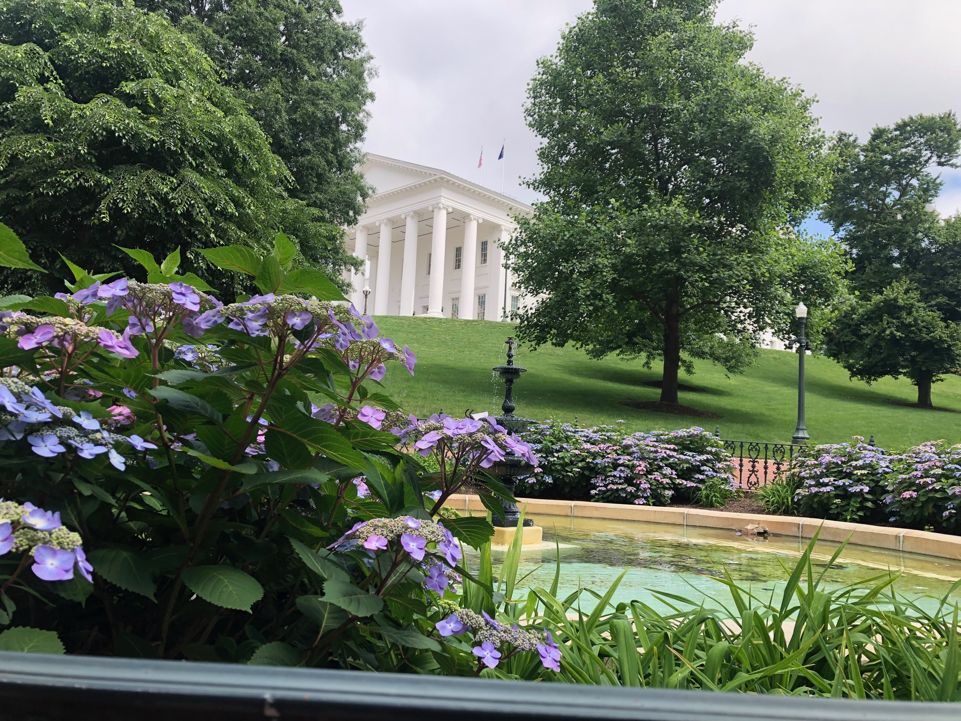

Sincerely,

Wes Bray

Wes Bray, President

Tom Tracy

Tom Tracy, Executive Director