EARTH DAY
APRIL 22, 2022
9:00 a.m. – 3:00p.m.
HARDING STREET URBAN AGRICULTURE CENTER
hardingstreetag@gmail.com
804-203-4829
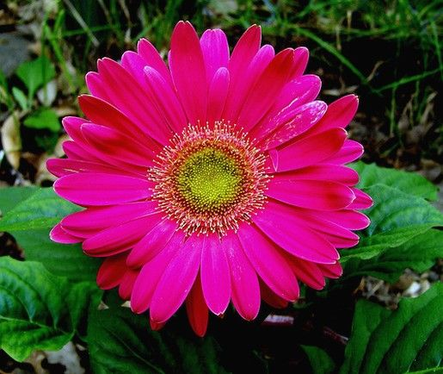
453 Harding Street – Petersburg, Virginia 23803
Join us as we:
Clean Orchards, Clean Beds, Stake Grapevines, and Clean Water Channels
____________________________________
Tools, Gloves, Garbage bags, Pickers, Water & Snacks Provided !!

